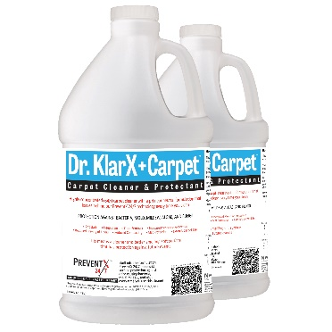
Dr. KlarX+ Carpet™ Use Instructions
Where to Use:
- This product is formulated for use on soft surfaces (carpet, upholstery, fabrics) that are not adversely affected by water.
- This product contains 0.67 % active in solution of PreventX 24/7™ for every ounce of concentrate used to make surface more durable and to protect the surface against the development of mold, mildew, and odors typically associated with bacteria.

Supplies Needed:
- Dr. KlarX+ Carpet™ 2ea/1-Gallon Containers of 10X Concentrate - Part Number: NEKCP21G10
- Water, spray applicator, carpet cleaning equipment
- Cloth types: Microfiber cloth or other lint-free non-abrasive cloth.

Prepare Cleaning Solution
The concentrate should be diluted using the following guidelines:
  - Routine maintenance: 2oz of concentrate per gallon of water (.01% active PreventX 24/7™)
  - Medium soiled surfaces: 4oz of concentrate per gallon of water (.02% active PreventX 24/7™)
  - Heavily soiled surfaces: 6oz of concentrate per gallon of water (.03% active PreventX 24/7™)
  - Spot cleaning / Pretreatment:
    - Lightly soiled areas 2oz of concentrate per quart (32oz)
    - Heavily soiled areas 4oz of concentrate per quart (32oz)

Spot Cleaning & Topical Cleaning of Fabrics:
- Prepare the spot cleaning solution based on the conditions of said surface to be cleaned.
- Spray directly on soiled areas and let stand for 2-3 minutes.
- Wipe away using circular motion and let dry.
  - Option: Extract moisture from surface using extraction machine

Pretreatment:
- Prepare the pretreatment cleaning solution based on condition of surface to be cleaned to improve performance.
- Spray directly on soiled areas and let stand for up to 30 minutes before cleaning.
- Clean soiled areas with extraction machine, steam machine or bonnet.

Extraction/Steam Cleaning:
- Fill tank of extractor with prepared cleaning solution and turn heater on. If you are using a non-heated unit, it is recommended to prepare cleaning solution using hot water.
- Follow manufacturer instructions for equipment being used.
- Remove all obstructions and vacuum to remove as much dirt as possible before extraction.
- If there are any noticeable stains or soiled areas, perform necessary spot cleaning (See pretreatment instructions).
- Pretreat surface if regular maintenance has not been performed or if soiled areas are visible. This pretreatment will free the bonds of dirt from the surface.
- Perform extraction, dry surface, and clean up in accordance with equipment manufacturer instructions.

Bonnet Cleaning:
- Follow manufacturer instructions for equipment being used.
- Remove all obstructions and vacuum to remove as much dirt as possible before cleaning.
- Using a pump-up sprayer, apply prepared cleaning solution to the entire surface allowing at least 5 minutes for prepared solution to settle onto surface. Spray more solution on visibly soiled areas or spots/stains.
  - Optional: Dip bonnet into prepared solution using mop bucket or other container.
- Run bonnet machine over entire surface.
- Flip the bonnet over or replace bonnet as it becomes soiled.
- Remove all moisture from surface using extracting equipment.
- Allow surface to dry before use.

A New Era of Scientific Solutions for Your Peace of Mind

To know more about our technologies or obtain more information on these products, please visit us at www.NewEraSOS.com, call us at 1‐888‐637‐6760 or send us an email at customerservice@NewEraSOS.com

